PRESS RELEASE
by NAGP 11/17/22

Going, Going, ALMOST Gone –
Lesser Prairie-Chickens in the Great Plains
By Ted Koch, Executive Director, North American Grouse Partnership (NAGP)

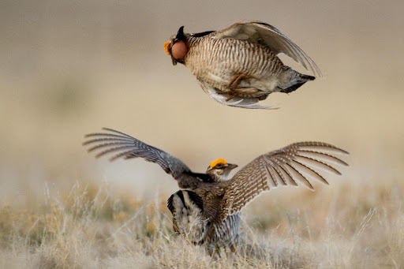

We’re almost done ignoring the slow-motion loss of southern Great Plains prairie ecosystems. Why? Because they are almost gone.

And the lesser prairie-chicken, the enduring, iconic wild prairie grouse found only on the largest remaining landscapes there, is almost gone too. Sadly, the U.S. Fish & Wildlife Service just listed the lesser prairie-chicken under the Endangered Species Act.

When Native Americans and pioneers waded through this sea of grass more than a century ago and fed themselves on wild lesser prairie-chickens, they could have never imagined the day when all that remained were a few patches of wild prairie and an endangered species.

Having lost 90% of our prairie heritage, are we careless enough to keep going until the last 10% is gone? Of course, our answer must be “NO!”

Conservationist Aldo Leopold said, “The grouse represents only a millionth of either the mass or energy of an acre, yet subtract the grouse and the whole thing is dead.” The beauty and integrity of the prairie has many faces - wild prairie grouse, wildflowers, wild pollinators - and the whole is worth saving before it is too late.

Consider one simple fact: Lesser prairie-chickens survive today ONLY because of caring private landowners who steward nearly all the remaining habitat. A resounding “Thank you!” to those landowners participating in voluntary conservation. If Americans are to save the last fragments of prairies and lesser prairie-chickens, these landowners and their neighbors deserve our support.

Voluntary, incentive-based conservation programs remain our greatest opportunity to positively impact this southern Great Plains landscape. The U.S. Fish & Wildlife Service cannot recover lesser prairie-chickens with regulations. Endangered species status will bring more money, expertise, and focus to support conservation efforts. However, it is the voluntary participation of landowners who hold the key to the future of these cherished places and iconic species.

Many landowner-conservationist heroes across the five-state region (Kansas, Oklahoma, Texas, New Mexico, and Colorado) are joining together to ask federal agencies for more strategic, focused, and efficient implementation of conservation programs. It is urgent that we act now to join their voices. Please let your state legislators and U.S. Senators and Representatives know that you support increased efforts to help landowners voluntarily conserve prairies. Let the Natural Resources Conservation Service, Farm Services Agency, U.S. Fish and Wildlife Service, and state wildlife agencies know too.

The science and our practical experiences are clear: we know how to act in support of conserving the last remaining prairies and wildlife who call them home. We have the tools available. But we need more strategic, focused, and sufficient funding to assist interested landowners. Let’s work together to ensure our grandchildren can see wild lesser prairie-chickens in wild prairie habitat. They are too important to let slip away.

To learn more about America’s prairie grouse, go to www.GrousePartners.org
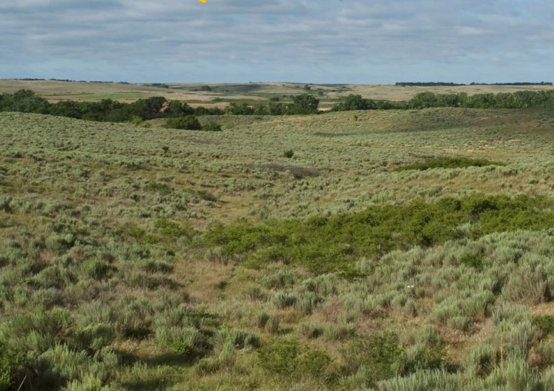

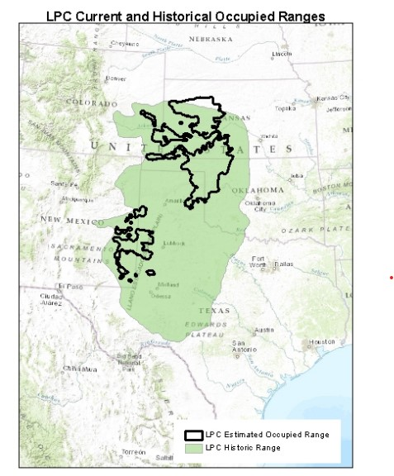

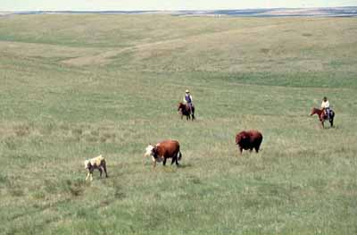

For interview requests or questions, please contact North American Grouse Partnership’s Executive Director Ted Koch (ted@grousepartners.org, 208-912-5233) or Communications Director Jodie Provost (jodie@grousepartners.org, 218-838-3553).

